Circle Generators creates a SVG image of a concentric circles of different colors on a 500x500 grid.

The user has selection control over the number of circles created and the number of colors used. Colors may be chosen from standard CSS colors palette with colors choices being unique up to the number of circles created. If number of colors is chosen supplied is less than the number of circles created, the colors will cycle and repeat.

This is an example 3 circles generated using 3 distinct colors

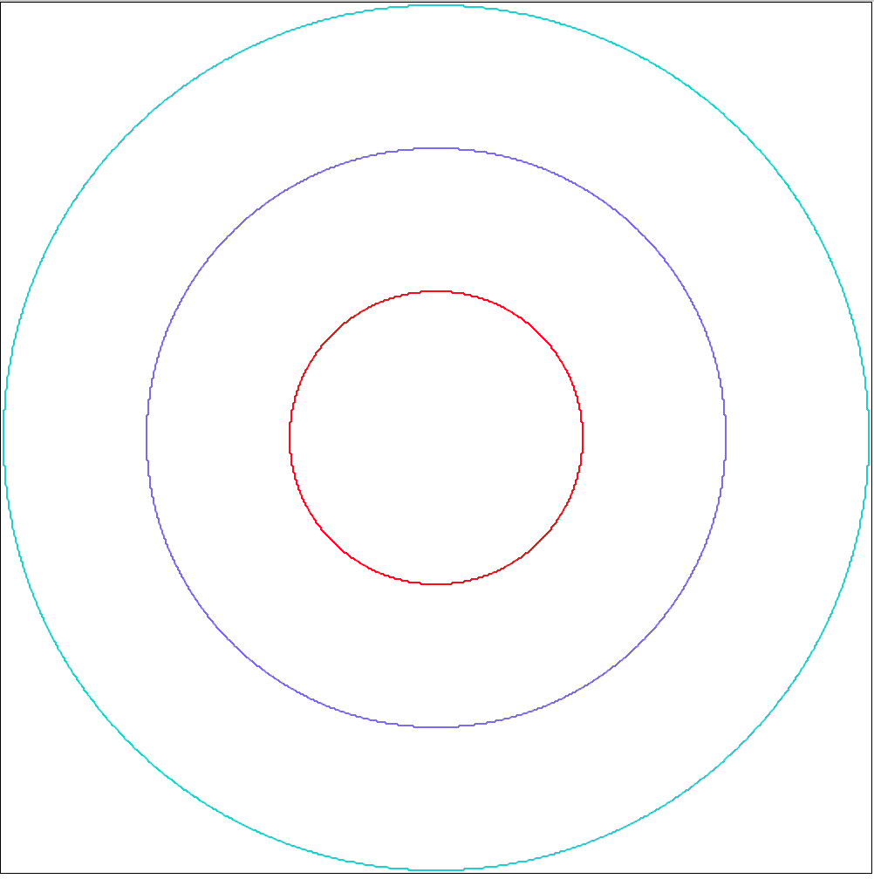

## How to use.

To use this program, from the Linux command line invoke



## Example

To generate the example above

